SALKANTAY TREK TO MACHU PICCHU –
Sept 2017 (8nights/9days)
FREEDOM CHALLENGE
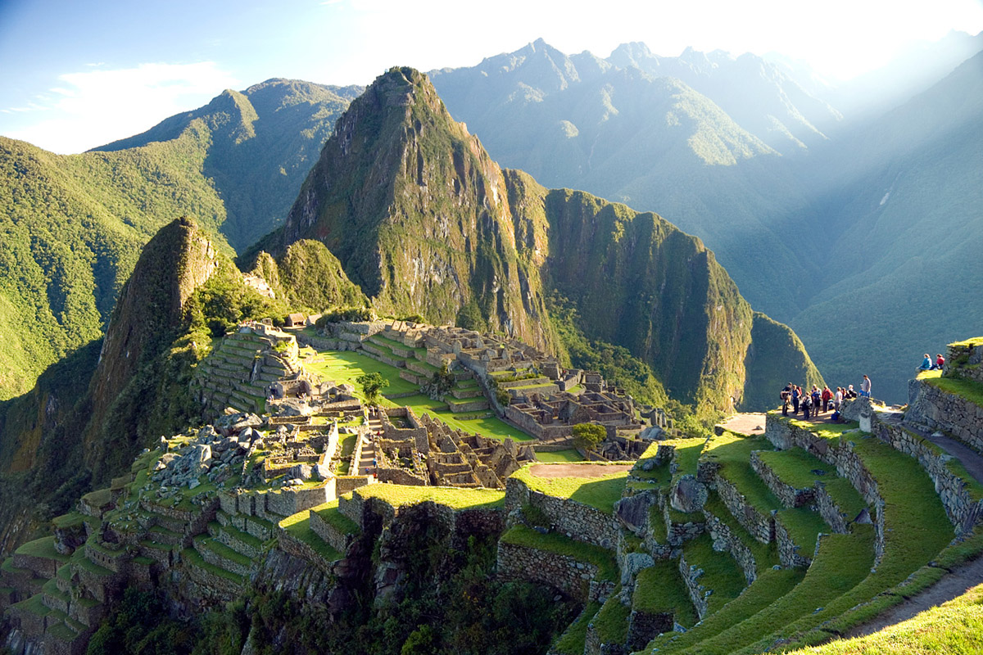
(6nights/ 7days on the trek)

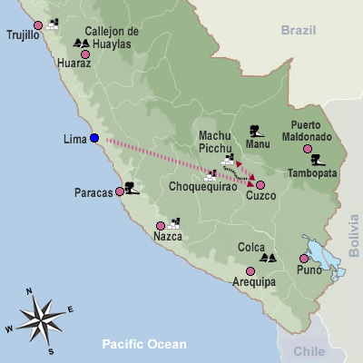
Salkantay Trek to Machu Picchu

Why this itinerary?
Spend 9 days exploring Inca sites in Peru, a fascinating and truly memorable experience.

Description
This trip is a lesser-traveled route in Peru to the lost city Machu Picchu. This trip is a perfect alternative for those who don't book the Inca Trail. The Vilcabamba area was the holdout for the crumbling Inca rebellion. The trail traverses the high Andean plateau, crossing passes as high as 4,750m - 15,585ft for an up-close view of the sacred Inca peak, Salkantay (6,280m - 20,598ft). The route then descends into the beautiful Aobamba valley with its tropical climate and vegetation. All along the way there are native Andean villages that time seems to have passed by. After a marvelous train ride, arrive at the spectacular citadel of Machu Picchu for a never to be forgotten guided-tour of this architectural marvel. Hidden under the dense foliage of a highland jungle, forgotten by the Incas themselves, Machu Picchu escaped the conquistadors and

eluded treasure hunters until Hiram Bingham brought the “Lost City of the Incas" to the world's attention in 1911. The intricate stonework of these enigmatic ruins is one of the finest examples of Inca masonry.
Highlights: Cusco, Sacred Valley, Salkantay Trail, and the world famous Machu Picchu!
Brief Itinerary

# | Area | Overview
1 | Cusco | Arrive Cusco airport. Welcome dinner & briefing. Overnight Costa del Sol Picoaga Hotel
2 | Sacred Valley | Sacred Valley, Maras & Moray acclimatization hike. Overnight Costa del Sol Picoaga Hotel
3 | Salkantay | Begin Salkantay Trail. Hike and overnight Soray Camp
4 | Salkantay | Salkantay Trail. Hike and overnight Huayracmachay Camp
5 | Salkantay | Salkantay Trail. Hike and overnight Collpapampa Camp
6 | Salkantay | Salkantay Trail. Hike and overnight Lucmabamba Camp
7 | Salkantay / Aguas Calientes | End Salkantay Trail. Hike to Train. Ride into Aquas Calientes. Overnight Casa Andina Classic Machu Picchu
8 | Machu Picchu | Machu Picchu tour (options to hike). Overnight Casa Andina Classic Machu Picchu
9 | Depart | Transfer to Cusco airport for departures
END OF SERVICES

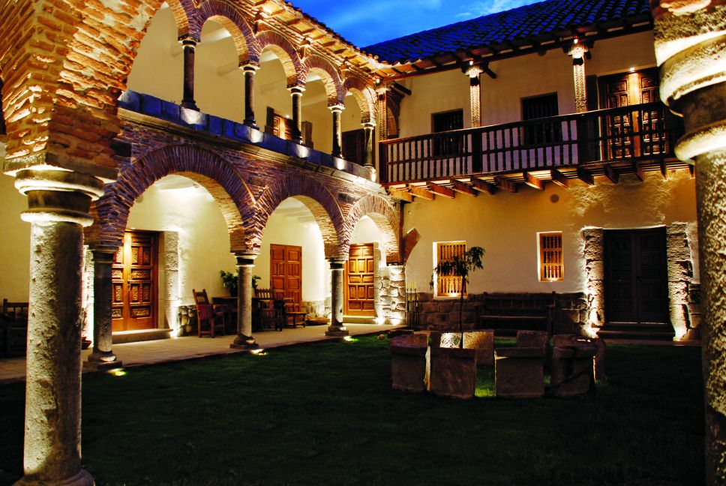
Detailed Itinerary
Day 1 / CUSCO

Upon arrival into Cusco airport you are personally met and transferred to your hotel in Cusco. There is a welcome dinner and briefing.

Overnight Costa del Sol Picoaga Hotel (Dinner)

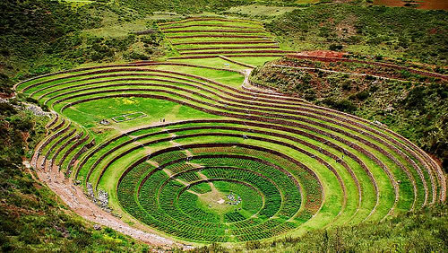
Day 2 / SACRED VALLEY / MARAS & MORAY
Today we get out of Cusco for the day and enjoy the splendor of the outlying region in the Sacred Valley of the Incas. We depart Cusco in the morning and go to the archaeological site of Moray, passing through the typical Andean farming village of Chincheros on the way. At Moray, we can observe the extensive circular terraces where the Incas once experimented with adapting plants to new climates. We leave Moray and hike on a path for 2 hours to the colonial Andean village of Maras where we enjoy a typical Peruvian lunch. From here, we begin our descent to the Saltpans, which have been harvested for hundreds of years. Surrounded by the incredible views of the fertile valley below and the snow-capped peaks of the Cordillera Urubamba, we continue hiking to the Urubamba River, where our vehicle will be waiting to take us back to our hotel in Cusco, arriving in time to freshen up before dinner.
Overnight Costa del Sol Picoaga Hotel (Breakfast, Lunch, Dinner)

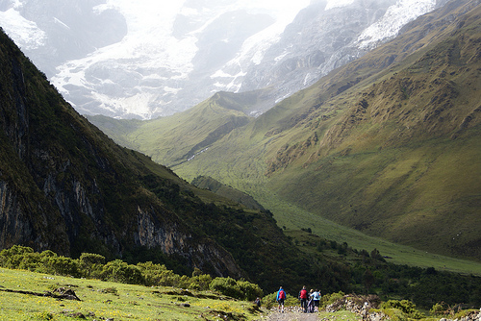
Day 3 / SORAY
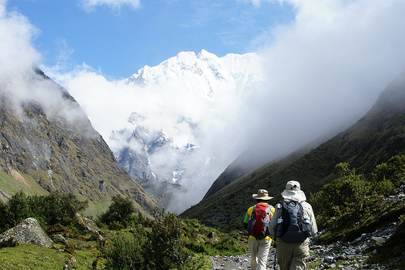
We leave Cusco heading west towards the Anta plateau. This is the spot where the legendary Inca Pachacutec defeated the Chanca tribe thus starting the expansion of the Inca Empire. We continue up to Huillque pass with its panoramic view of the east side of the Vilcabamba range. On our way down towards the warm Limatambo valley we’ll stop at the Tarahuasi archeological site for a short visit. After passing through Mollepata (2,850m / 9,350ft), a small and very typical Andean community, we begin our trek in Marco Casa (3,200m / 11,00ft) approx. 4 hours. Since this is a rich agricultural area, we’ll see local villagers at work and possibly interact with them. The route continues towards the highlands with its very interesting and colorful surroundings, until we finally get a glimpse of Mt. Humantay (5,917m / 19,414ft). After crisscrossing several streams and passing through some dense bush areas, we reach our campsite on the immense Pampa Soray (3,800m / 12,468ft).
Overnight Soray Camp (Breakfast, Lunch, Dinner)

Day 4 / HUAYRACMACHAY
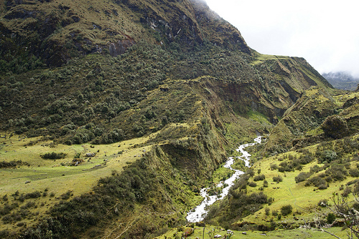
We start our day with a hearty breakfast before starting the trek through one of the most impressive areas in the Vilcabamba range. Our hike will go to the base of the south face of Salcantay, one of the Inca's sacred mountains (6,217m / 20,575ft). We climb up on the southwest side of the Salcantay moraine to a high pass called Portachuelo (4,750m / 15,585ft). On this rocky area we may catch a glimpse of a lively vizcacha, a unique type of gray Andean rabbit and perhaps see a condor, the world’s largest flying bird. We will be very close to the huge south face of Salkantay, almost within touching distance. Don’t forget to carry a small rock all the way from Mollepata, since, according to Inca tradition; travelers must deposit one on an “apacheta” (a pyramid of rocks) at the pass as an offering to the “apus” (mountain spirits). The route then descends towards the Amazon basin and the Andean valley of Huayracmachay. Just past here we set up camp (4,100m / 13,45ft).
Overnight Huaryracmachay Camp (Breakfast, Lunch, Dinner)

Day 5 / COLLPAPAMPA

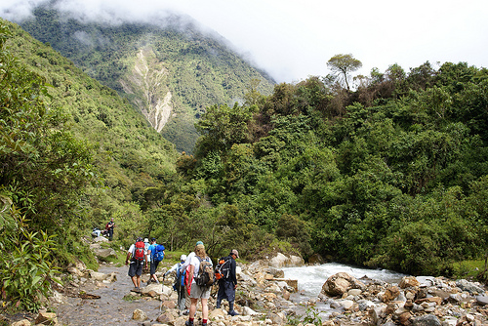
Today we’ll follow the route that the last Incas used to escape the Spanish in this remote region of the Vilcabamba range. The trail continues along the left bank of the Sunchucata River. On the way down toward Rayanpata we’ll observe how the landscape changes from arid highlands to tropical jungle. Further down, we see where three streams meet to form the Santa Teresa River. We continue on to the community of Collpapampa (2,900m / 9,515ft). A special lunch waits for us, the trail continues along the left bank of the Santa Teresa River. As we lose altitude, the weather warms but remains at a comfortable temperature.

Overnight Collpapampa Camp (Breakfast, Lunch, Dinner)

Day 6 / LUCMABAMBA

The trail crosses several creeks and passes by delightful waterfalls. Vegetation becomes more abundant and we'll see lots of multicolored flowers, butterflies and

noisy little green parrots. Our lunch break will be on the riverbank before continuing to the campsite near the village of La Playa, also known as Miscabamba (2,200m / 6,562ft). The families who live here are socially organized in the same manner as their Inca ancestors; in an “ayni” or cooperative system designed to share construction and farming work. There will be a good chance to play soccer or volleyball with the locals. Overnight Lucmabamba Camp (Breakfast, Lunch, Dinner)
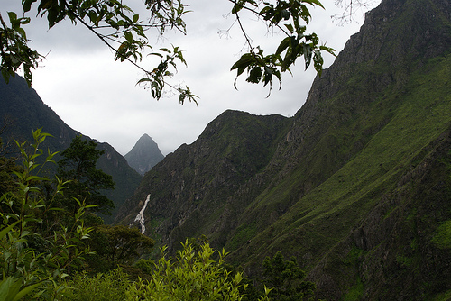
Day 7 / AGUAS CALIENTES

We start our last climb, crossing Llactapata pass. There are Inca sites just on the other side of the pass and a spectacular panoramic view of the outline of Machu Picchu. Then we descend into the rich, tropical Aobamba valley with its fields of oranges, paltas (avocados), bananas, granadillas (passion fruit), coffee and sugar cane. After saying good-bye to our camp staff, we board the train for a 30-minute ride to the town of Aguas Calientes that sits just below Machu Picchu.

Overnight Casa Andina Classic Machu Picchu (Breakfast, Lunch, Dinner)
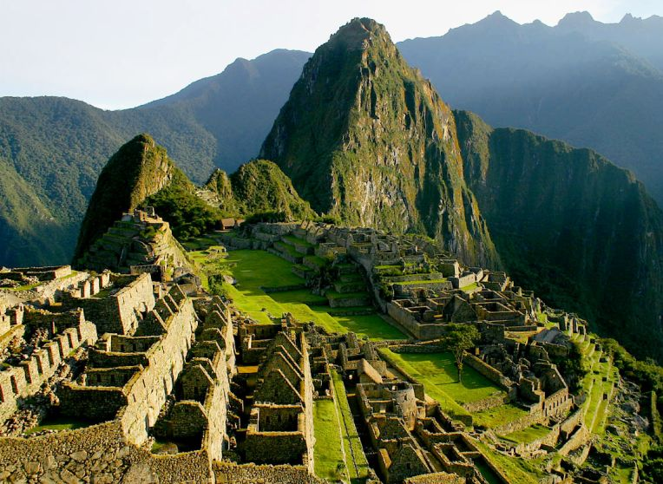
Day 8 / MACHU PICCHU

After breakfast we will take the bus up to the archeological site of Machu Picchu to begin our guided tour of this world-renowned historical Inca city. The geographical location of this important site is breathtaking; located high on a mountainside in the cloud forest ecosystem. Exploring the site, we can appreciate the skill developed by

the Incas to thrive in this difficult environment. We will be exploring the most important site developed by the Incas, with its observatories, temples, water fountains and sundials. The amazing stonework stands out in a wide variety of architectural styles. You have options to hike Machu Picchu or Huayna Picchu (which requires permits so plan accordingly). You enjoy the site at leisure and return to your hotel at your own pace. Overnight Casa Andina Classic Machu Picchu (Breakfast, Lunch, Dinner)
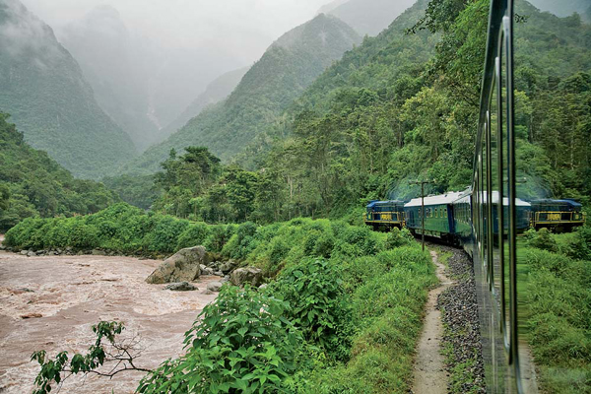
Day 9 / DEPART
Today you take a train to Ollantaytambo and then you are transferred to Cusco airport for your departures.
(Breakfast)

END OF SERVICES

ACCOMMODATIONS

HOTEL COSTA DEL SOL PICOAGA is a few steps away from the Main Plaza in Cusco, a place that has preserved both the warmth and the imposing beauty of a big old Colonial house with a service that will make you feel at home. The Colonial rooms are located around the main patio and maintain the original details of those times. All rooms are fully carpeted and feature air conditioning and heating.
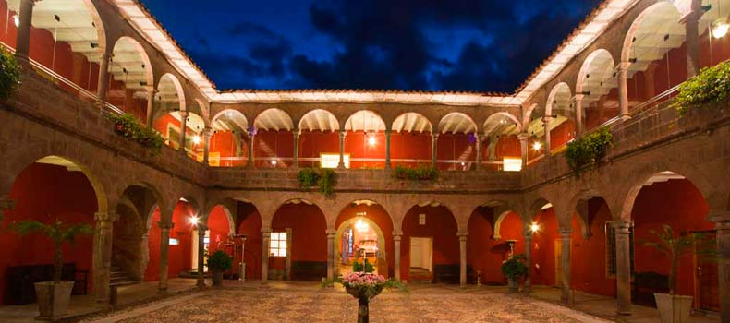

SALKANTAY TRAIL PRIVATE CAMP is set up every step of the way and ready for when you arrive into camp in the afternoon. A mess tent contains a table, backed chairs, and all cutlery. Guest tents fit 2 people comfortably with a thick sleeping mattress and sleeping bag all set up for a comfortable sleep. A separate toilet tent and shower tent is provided for the group.

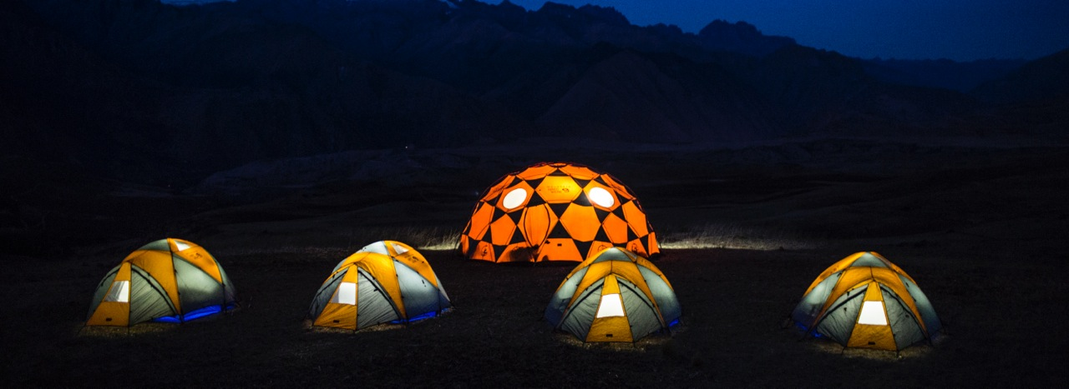

CASA ANDINA CLASSIC MACHU PICCHU is a friendly and cozy hotel that provides you a strategic loction in Aquas Calientes, nearest access point to the historic sanctuary of Machu Picchu. This hotel has 54 new and comfortable rooms where you can relax and restore energy to enjoy the visit to the citadel. A spectacular view of the Vilcanota river provides a special atmosphere for the restaurant.

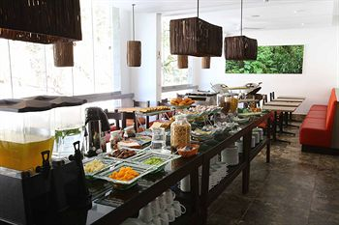

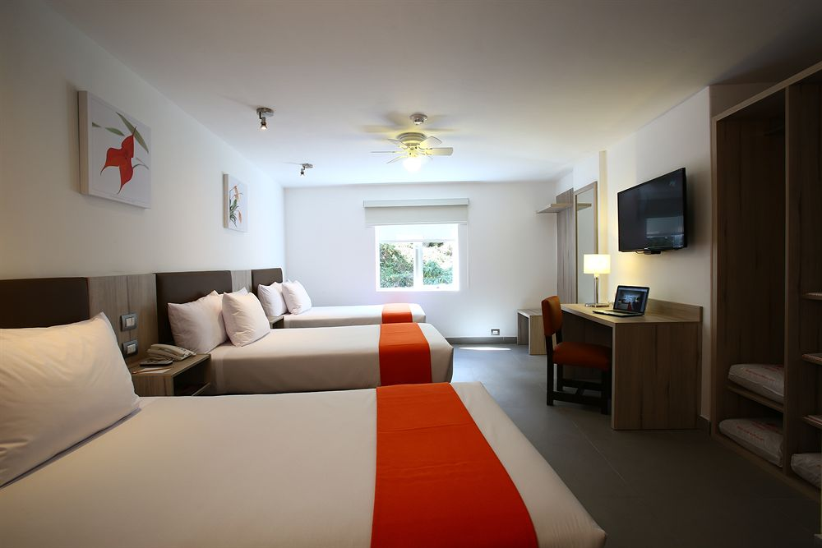

DESTINATIONS
Peru, South America
The Republic of Peru is a country in western South America. It is bordered on the north by Ecuador and Colombia, on the east by Brazil, on the southwest by Bolivia, on the south by Chile, and on the west by the Pacific Ocean. Peruvian territory was home to the Norte Chico civilization, one of the oldest in the world, and to the Inca Empire, the largest state in Pre-Columbian America. The Spanish Empire conquered the region in the 16th century and established a Viceroyalty, which included most of its South American colonies. Peru achieved independence in 1821, and has undergone political unrest as well as periods of stability and economic upswing. The earliest evidence of human presence in Peruvian territory have been dated to approximately 9,000 years BC. In the 15th century, the Incas emerged as a powerful state. Andean societies were based on agriculture, using techniques such as irrigation and terracing; camelid husbandry and fishing were also important. Organization relied on reciprocity and redistribution because these societies had no notion of market or money. In 1532, a group of conquistadors led by Francisco Pizarro defeated and captured Inca Emporer Atahualpa. In the early 19th century, while most of South America was swept by wars of independence, Peru remained a royalist stronghold. Independence was achieved after military campaigns of Jose de San Martin and Simon Bolivar. Peru for decades experienced turmoil, drug trafficking and massive political violence. Upon the presidency of Alberto Fujimori, the country started to recover but still there were accusations of authoritarianism, corruption, and human rights violations, which resulted in his resignation.
The Andes mountains run parallel to the Pacific ocean and divide the country into 3 geographic regions; The coast, the highlands, and the jungle. Peru unlike other equatorial countries does not have an exclusively tropical climate, the influence of the Andes cause great climatic diversity within the country. Because of its varied geography and climate, Peru has a high biodiversity with 21,462 species of plants and animals, about one-fourth being endemic. The Peruvian government has established several protected areas for their preservation. The Incas maintain architectural achievements including the construction of Machu Picchu.

Additional Information

Entry Requirements
No visas required for Peru. A passport valid for six months after date of entry is required. Visitors must hold return/onward tickets and all documents required for their next destination.

Vaccinations
Hepatitis A and B, Tetanus, and Typhoid immunizations are recommended for all travelers. Malaria prophylaxis is recommended if you are traveling to jungle regions and you should consult your local doctor or physician to advise which malaria medication is best suited for you. Information on vaccinations and other health precautions, such as safe food and water precautions and insect bite protection, may be obtained from the CDC’s Internet site at http://www.cdc.gov/travel

Weather
Cusco, Peru
Month Jan Feb Mar Apr May Jun Jul Aug Sep Oct Nov Dec
Average High 65 65 66 67 67 66 66 67 68 69 69 69
Average Low 43 43 43 41 36 32 32 35 39 41 42 43

Communication
Peru – The international access code for Peru is +51, and the outgoing code is 00, followed by the relevant country code (e.g. 0044 for the UK). City/area codes are in use, e.g. (0)1) for Lima. A mobile phone operator provides a GSM 1900 network with coverage limited to major towns and cities. Peru is well connected to the Internet with a proliferation of inexpensive Internet kiosks, called cabinas pública, available on street corners in most towns and cities

Electricity
Peru - Electrical current is 220 volts, 60Hz (Arequipa 50Hz). Two-pin, flat blade and round plugs are standard

Gear List
**A comprehensive gear list will be provided for essential clothing items to bring whilst on safari or activities. Please visit the Adventure International Gear & Apparel Shop: http://adventureinternational.newheadings.com All proceeds are donated to Kilimanjaro Porters Assistance Project.

Travel Advisories
Make two photocopies of valuables such as your passport, tickets, visas and travelers' cheques. Keep one copy with you in a separate place to the original and leave another copy with someone at home.

Be sure to inform your credit card company as well as your bank you will travel internationally into Africa. This will eliminate any credit card holds for fraudulent activity.

Currency
Carrying cash, an ATM or traveler’s check card and also a credit card that can be used for cash advances in case of emergency is advisable. The best places to exchange money are normally bureau de change, which are fast, have longer hours and often give slightly better rates than banks. Local currency is Peruvian Nuevo Sol (PEN), and it is advised to carry hard notes of USD. Better hotels, lodges, and camps might accept credit cards, however it is advised to withdraw cash when visiting remote areas and villages.

Government
Peru – is a constitutional republic

Religion
Roman Catholic 81.3%, Evangelical 12.5%, other 3.3%, unspecified or none 2.9%

Ethnic Groups
Peru is a multiethnic country composed of Amerindians 45%, Mestizos 37%, Europeans 15%, Afro-Peruvians 2%, Asians and others. The Andes are the heart of indigenous populations and white people are mostly found on the coast of Spanish, Italian, British, French, German, Irish, and Croation descent.

Languages
The official language is Spanish but the other predominant languages are Quechua, Aymara and Amazon languages like Urarina.

Economy
Peru has one of the stronger and fastest growing economies in the Americas. Peru is an emerging market oriented economy characterized by a high level of foreign trade and still high level of inequality, its econmy is diversified although the commodity exports is important, the trade and industry are centralized in Lima but the agricultural exports have created development in all the regions. Peru’s main exports are copper, gold, zinc, textiles, and fish meal. Peru agricultural exports are highly appreciated and include artichokes, grapes, avocados, mangoes, peppers, sugarcane, organic coffee and premium cotton. Peru has large coca leaf cultivation, while the government has reduced productions and prohibits narcotics trafficking, the industry ranges from $300-$600 million.

Climate
The climate of Peru is very diverse, with large variety of climates and microclimates, including 28 of the 32 world climates. Such a diversity is chiefly conditioned by the presence of the Andes mountains and the cold Humboldt Current. In general, the climate on the coast is subtropical with very little rainfall. The Andes mountains observe a cool-to-cold climate with rainy summers and very dry winters. The eastern lowlands present an Equatorial climate with hot weather and rain distributed all year long.

